SmartCityAdvisor

**A close up of a logo

Description generated with very high confidencePOLITECNICO** MILANO 1863

ASSIGNMENT 1 – RASD

Requirement Analysis and Specification Document

A Software Engineering II Project,

made by Luca Favano 899224

V1.0 - 12/05/2018

Table of Contents:

1 - Introduction 4

1.1 Purpose 4

1.2 Scope 4

1.2.1 Goals 4

1.3 Definitions, Acronyms, Abbreviations 4

1.3.1 Definitons 4

1.3.2 Acronyms 5

1.3.3 Abbreviations 5

1.4 Revision History 5

1.5 Reference Documents 5

1.6 Document Structure 5

2 - Overall Description 7

2.1 Product Perspective 7

2.1.1 Statechart 7

2.1.2 Class Diagram 8

2.2 Product Functions 9

2.2.1 CO2 -Based Traffic Management 9

2.2.2 Complete Traffic Management 9

2.2.3 Summarize and Provide System Data 9

2.2.4 Others (not implemented) 9

2.3 User Characteristics 10

2.3.1 Actors 10

2.4 Assumptions, Dependencies and Constraints 10

2.4.1 Assumptions 10

2.4.2 Dependencies 11

2.4.3 Constraints 11

3 – Specific Requirements 12

3.1 External Interface Requirements 12

3.1.1 User Interfaces 12

3.1.2 Hardawre Interfaces 15

3.1.3 Software Interfaces 16

3.1.4 Communication Interfaces 16

3.2 Functional requirements 16

3.2.1 Requirements Definition 16

3.2.2 Defining Scenarios 17

3.2.3 Use Case Diagrams 19

3.2.4 Use Case Descriptions 20

3.2.4 Sequence Diagrams 24

3.3 Performance Requirements 27

3.4 Design Constraints 27

3.4.1 Standards Compliance 27

3.4.2 Hardware Limitations 27

3.5 Software System Attributes 27

3.5.1 Reliability 27

3.5.2 Availability 27

3.5.3 Security 27

3.5.4 Maintainability 27

3.5.5 Portability 28

4 – Formal Analysis Using Alloy 29

5 – Effort Spent and References 36

# 1 - Introduction

## 1.1 Purpose

This Document is the Requirement Analysis and Specification Document thus its goals are to analyze the needs of the customer in order to model the system while describing it in terms of functional and non-functional requirements. It’s a useful document to the developers since it can highlight the limits and constraints of the software by showing typical use cases.

## 1.2 Scope

SmartCityAdvisor is a service thought specially for the city of Milan that based on several sensors and actuators can limit the traffic throughout the city. Such service is mostly useful to contain the level of CO2 in the air but may also be used in case of special situations that require it.

Such service is possible thanks to sensors that track the level of CO2 in the air, the number of cars that enter in the city center and the available spots in each parking lot of the city.

SmartCityAdvisor implemented a sophisticated actuators system that is able to divert the traffic away from the city center when needed, this is obtained by controlling the traffic lights and alerting the citizens through the mobile app and big displays that can be seen when entering the city.

### 1.2.1 Goals

**[G1]** Limit the traffic accordingly to current CO2 levels in Milan.

**[G2]** Warns the citizens of a change of the current status

**[G3]** Provide users with up-to-date information retrieved from the sensors

**[G4]** Manage the traffic accordingly to special events taking place

**[G5]** Simplify the process of finding and reserving an available parking spot

**[G6]** Providing Superusers the possibility to manage events and emergencies

## 1.3 Definitions, Acronyms, Abbreviations

### 1.3.1 Definitions

* **Sensor:** A component of that communicates with the system at regular intervals providing useful information for the system to work correctly**.**
* **Actuator:** A component that allows the system to have an impact on the environment based on choices that can be taken automatically or manually,
* **City Center:** An area of Milan which characteristics need to be preserved and kept constant over the time.
* **CO2 Level:** Current amount of CO2 particles detected by the sensor and measured in ppm (particles per million).
* **Superuser:** A user of the app that has higher privileges compared to a “normal” user which is a common citizen that downloaded the app.

### 1.3.2 Acronyms

* **RASD:** Requirement Analysis and Specification Document
* **UML:** Unified Modeling Language
* **IEEE:** Institute of Electrical and Electronic Engineers
* **DBMS:** Database Management System
* **HTTP:** Hypertext Transfer Protocol

### 1.3.3 Abbreviations

* **[Gn]:** n- Goal
* **[Dn]:** n- Domain Assumption
* **[Rn]:** n- Functional Requirement

## 1.4 Revision History

* **V1.0:** First Version, Released on 12/05/2018
* **V1.1:** Typo Corrections, Released on ??/05/2018
* **V1.2**: Final Version, Released on ??/06/2018

## 1.5 Reference Documents

* **Specification Document:** “Assignment-for-the-second-project.pdf”
* **Alloy Specification** found on beep and google
* **Past Project Examples** taken from beep
* **IEEE Recommended Practice** for Software Requirements Specifications.

## 1.6 Document Structure

This document will be structured into five different sections:

* **Section 1: The introduction**, a brief description of the project, the terms that will be used and some useful knowledge.
* **Section 2: Overall Description**, more specific information about the service that will be provided and its functions, including its constraints and limits.
* **Section 3: Specific Requirements**, the complete requirements and constraints of the project. Both functional and non-functional requirements are discussed together with the Design Constraints and the attributes of the system.
* **Section 4: Formal Analysis**, a representation of the structure of the project obtained using the Alloy language.
* **Section 5: Effort Spent + References**, containing all the information used while writing the document and the time spent doing it.

# 2 - Overall Description

## 2.1 Product Perspective

The SmartCityAdvisor system will be developed will be developed from scratch, it will be server-sided and will also include an anonymous app and website.  
This service can then be used on every mobile phone or computer with an active internet connection.

The system will interface with sensors, actuators, displays and the app while the app will just show the results to the customers without them needing to interact with it, if not to sort out the relevant results. The GPS in the mobile version could be used to obtain better and faster results on the go.

The displays won’t show all the information but only the ones most relevant to the road the displays are mounted on or the ones immediately linked to it.

Having information about the CO2 level and the availability of parking spots may also be interesting for the citizens and could be further used in future developments of this system.

### 

### 2.1.1 Statechart

Here is the statechart related to the possible states that the system can assume:

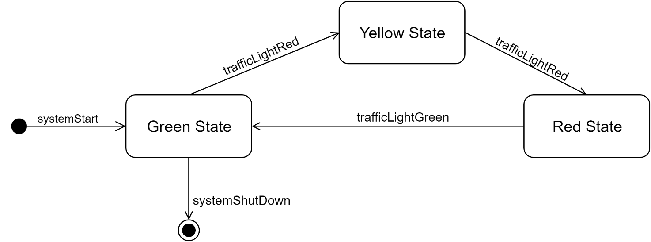

### 2.1.2 Class Diagram

A screenshot of a cell phone

Description generated with very high confidence

## 2.2 Product Functions

For this project we are asked to develop SmartCityAdvisor, a system that includes many sensors that in the beginning won’t be used extensively, in fact we are also asked to contribute to the system by suggesting new functionalities that should be implemented.

### 2.2.1 CO2 -Based Traffic Management

The main function that the system should offer is a traffic management system based on the CO2 level readings in the air that are taken by the sensors.

In this case the sensors send their data to the control center every two hours, when the data is found to be higher than a chosen threshold the traffic management system will change its status and start transitioning from a “green” status to a “red” one.  
When in the red status the traffic will be deviated from the city center to other roads thanks to the actuators connected to the traffic lights.

This system also includes a middle status that is the “yellow” one, when in such status the citizen will be warned of the imminent situation via the mounted displays and the app. This status could go on approximately from 30 to 60 minutes based on the current traffic situation, for an emergency this status could be skipped completely.

### 2.2.2 Complete Traffic Management

Given the availability of so many useful sensors an easy to identify function would be to make the system more complex and thus better.

Based on the other two sensors we could easily make an esteem of the cars that are currently circulating, in fact we have both the number of cars that enter the city center and the number of available parking spots, which is strictly linked to the number of parked cars.

This way we can’t obtain an exact number but still give a concrete esteem. Based on this extra information we can make better choices on when to limit the traffic in the city center, especially when is it a good time to restore the “green” status.

### 2.2.3 Summarize and Provide System Data

By making the system data available to the citizens via the app we may provide useful services, on top of them the searching of a parking spot will be easier thanks to knowing the availability of spots for every parking lot of the city center.

All the data read by the sensors will then be aggregated and then made publicly accessible on the app.

### 2.2.4 Others (not implemented)

Another possible function would be to suggest the best alternative solution to the users in case of a sudden change of the system status, for example which public transport (if any) would allow them to arrive on time to their destination.

This last function won’t be taken into consideration in this project due to the project group limited dimension.

## 2.3 User Characteristics

In this section will be discussed the actors that may interact with the system.

### 2.3.1 Actors

* **Citizen:** A person that is circulating in the streets of Milan and gets some basic information from the Display mounted around the city.
* **User**: A person that downloaded SmartCityAdvisor app and is able to retrieve more in-deep information about the current situations of the streets.
* **SuperUser**: A special user that signed in the app with special credentials and is now able to use extra functions such as making a new request for a special event happening in the future
* **Control Management Worker:** A person that is allowed to interact directly with the system to modify the current status in case of problems or emergency situations, send notifications to users or insert events in the DB

## 2.4 Assumptions, Dependencies and Constraints

### 2.4.1 Assumptions

For this system to works correctly we need to assume the good behavior of every citizen, it is implied that users should pay attention to the displays mounted on the streets or try to use the app so that they will have an adequate time to modify their plans and won’t cause troubles to the circulation.

Another aspect that is assumed is that a red traffic light should be seen as a rule that can’t be violated.

Lastly, we assume that the sensors make their readings in an anonymous way so that the privacy of the citizens won’t be violated.

The following assumptions are also necessary:

* **[D1]** Sensors work with an adequate precision, providing readings at the right times.
* **[D2]** In case of problems with sensors, some backups are always available until the broken ones are fixed.
* **[D3]** Sensors are provided in the right number, checked by their ID and won’t provide duplicated data.
* **[D4]** Actuators control the traffic lights in the wanted main intersections and not the ones in any different location.
* **[D5]** The “yellow” status is changed automatically after a given amount of time or manually by a worker in case of exceptions.
* **[D6]** Notifications to the users are sent and received immediately
* **[D7]** Superusers can’t share their credentials with anyone else

### 2.4.2 Dependencies

No dependencies have been spotted up to this version of the system, but this may be updated in the future.

### 2.4.3 Constraints

Even if the app will be very light it still have some hardware limitations described as follows:

* The systems used to open the app shouldn’t be too old, for a phone having iOS or an Android system is enough while a computer should use a modern browser.
* An internet connection is always necessary to retrieve the latest information from the system, it is care of the citizens to make sure the information they are reading are up-to-date and not some cached data.

Since the information provided by our system are very important for other apps to work properly (e.g. Google Maps) a public interface should be provided in the near future.

# 3 – Specific Requirements

Let’s now analyze all the aspects seen in the section number two, such aspects might become useful to the development team.

## 3.1 External Interface Requirements

### 3.1.1 User Interfaces

The user interfaces are strictly related to the app, which include only few goals of the system, while other goals that actually manage the traffic won’t be shown in this section.

The following images represent the wireframes of some of the main pages of the SmartCityAdvisor app.

The obtained app is very light and simple, easy to use and thus user-friendly. Both the versions have the same functions with the same structure. It’s divided into 4 main sections: Home, News, Data and Sign-in.

All the information needed can be obtained with few clicks and they are provided by the system automatically.

Other extra sections are omitted but could easily be added, for example the “contact us”, “about us”, “FAQ” sections.

A screenshot of a cell phone

Description generated with very high confidence

Figure 1: The landing page of the app shows the current traffic situation

A screenshot of a cell phone

Description generated with very high confidence

Figure 2: The news section shows the main events coming soon (e.g. A VIP that’s coming to visit Milan, such event is known well before it takes place and citizens should be warned)

A screenshot of a cell phone

Description generated with very high confidence

Figure 3: The data section shows the history of the sensors readings

A screenshot of a cell phone

Description generated with very high confidence

Figure 4: The data section also includes a function to find the nearest available parking spots, here some options are given, the user can then choose the one he prefers.

A screenshot of a cell phone

Description generated with very high confidence

Figure 5: To reserve a parking spot the user has to register by filling a short form, by doing this he will become a registered user but not a superuser.

A screenshot of a cell phone

Description generated with very high confidence

Figure 6: The sign-in section allows superuser to login into their special accounts, by inserting username and password

A screenshot of a cell phone

Description generated with very high confidence

Figure 7: Once that a superuser logon onto the website they have access to a special set of functions that directly interact with the system

### 3.1.2 Hardawre Interfaces

The application could run on any device with an internet connection, a GPS is also preferred (especially for the “find me a parking spot” function) but not required. Possible devices would be iOS phones, Android smartphones, tablets and Computers thanks to the responsivity of the developed app..

### 3.1.3 Software Interfaces

The system depends heavily on server-side operations that achieve the traffic management.

Popular APIs could be used to reduce the development cost, google maps API could easily be integrated as shown in the wireframes. This API could also be useful to retrieve real-time traffic information that could be integrated in our app.

To suggest an alternative path in case of an emergency we also would need the APIs offered by the Milan companies that provide public transportation services.

Some software requirements may be Android 4.0 or higher and iOS 7 or Higher.

### 3.1.4 Communication Interfaces

To communicate and send notification to the app users we use HTTP and XMPP protocols in order to send messages to GCM server, up to 1000 messages with a single HTTP request

## 3.2 Functional requirements

### 3.2.1 Requirements Definition

**[G1]** Limit the traffic accordingly to current CO2 levels in Milan.

* **[R1.1]** The system will automatically register the reports provided by the sensors
* **[R1.2]** The system will monitor the data and automatically make an action when moving after a threshold
* **[R1.3]** The system may change its traffic status in any moment, in any possible status

**[G2]** Warns the citizens of a change of the current status

* **[R2.1]** After a change in the system status citizens will be notified immediately and automatically by the system
* **[R2.2]** The displays text will be changed and show relevant information
* **[R2.3]** The app users will receive a notification on the app sent by the system

**[G3]** Provide users with up-to-date information retrieved from the sensors

* **[R3.1]** After data is received from the sensors it is categorized and added to a DB
* **[R3.2]** Relevant data is automatically loaded from the DB to the website every few hours
* **[R3.3]** The user can see the data by opening SmartCityAdvisor and navigating to the right section

**[G4]** Manage the traffic accordingly to special events taking place

* **[R4.1]** The user has to own superuser credentials
* **[R4.2]** The user has to login on the website using the right credentials
* **[R4.3]** The superuser has to navigate into its personal area and add a special event
* **[R4.4]** Superuser has to fill the form, the provided information will be then added to the DB
* **[R4.5]** The system will send an email to the superuser to confirm if the operation was successful

**[G5]** Simplify the process of finding and reserving an available parking spot

* **[R5.1]** User has to be logged in
* **[R5.2]** If the user is not logged in he needs to register by navigating to the right section and filling the forms
* **[R5.3]** The system will send a link to the email provided to conclude the registration
* **[R5.4]** The logged in user must look for a parking spot and choose which one to reserve
* **[R5.5]** The system will take the reservation and send it to the desired parking lot system
* **[R5.6]** The system will confirm the successful reservation by sending an email to the user

**[G6]** Providing Superusers the possibility to manage events and emergencies

* **[R6.1]** The Superuser has to be logged in
* **[R6.2]** The superuser has to reach it’s personal area by navigating to it
* **[R6.3]** Special forms to report emergencies, add/remove events can be found in the personal area

### 3.2.2 Defining Scenarios

1. **A foreign president will visit Milan:**

**When the appointment is confirmed and the news start spreading around the SmartCityAdvisor administrative team will take care of warning the citizens.**

**To do so a staff member will open the SmartCityAdvisor mobile application and move into the sign-in section with a click. After entering this section, he will insert his username and password and then submit. If the submit is successful (the credentials should be already present in the system DB) he will have access to some special features.**

**Special features include the option to add an event that will require the city center to be closed for a certain amount of time. After he filled the form with the required information, such information will be added to the DB and users will be notified.**

1. **There’s an emergency in the city center**

**A bad event happened in Milan and many citizens reported such situations to the authorities, based on an agreement between the police stations in Milan and the SmartCityAdvisor team, a policeman immediately warns the staff about it.**

**After being warned the staff may access again the “superuser” features but this time will select the “emergency” option. Such option will suddenly block the accesses to the city center (without keeping the “yellow” system state) and users will be notified.**

1. **I need a parking spot!:**

**A citizen that already downloaded the SmartCityAdvisor app in the past is now traveling with his family around Milan, they are late for their appointment but unluckily they can’t find any parking spot. Their choice is to open the app, navigate to the “Data” section and press the “find a parking spot” button.**

**The system will automatically suggest him the nearest parking lots with available spots, the user will then choose the one nearest to the place they have to reach and drive to it.**

1. **Why is the street closed?!**

A woman is going to the city center to have some shopping with her friends, when she’s almost there she finds out that the access to the center is not possible. The woman has no idea why is this happening since she has ignored the displays mounted on the street. Luckily she remembers that a friend suggested her this useful app called SmartCityAdvisor, she immediately download the app in the homepage learns that the city center is closed.

She wants more information and navigate to the Data section, here she finds out that the CO2 level is too high, to not endanger the population the access to the center is open only to the residents.

### 3.2.3 Use Case Diagrams

Use case for “normal” app users, that can be guests or become user after registration:

A close up of a logo

Description generated with high confidence

Special use case for the superursers that have more advanced functions:

A close up of a map

Description generated with high confidence

### 3.2.4 Use Case Descriptions

|  |  |
| --- | --- |
| **User Registration** | |
| Actor: | Guest |
| Input Conditions | The guest is on the homepage, haven’t registered yet |
| Events flow | Guest clicks on the Sign In section  Guest clicks on “register”  Guest fills in the required information and sends them  The system saves the information  The system sends a confirmation email  Guest follow the instruction on the email |
| Output Conditions | The process ends successfully and the guest is redirected on the sign in page |
| Exception | The guest already had an account  The guest doesn’t follow the instruction on the email  The guest inserted invalid information  The system is not reachable |
| Reached Goals | [G5] [G2] |

|  |  |
| --- | --- |
| **User Login** | |
| Actor: | Guest |
| Input Conditions | The guest is on the homepage, have already registered |
| Events flow | Guest clicks on the Sign In section  Guest insert username and password  Guest send the information to the server  The system evaluates the received credential  The Guest is now upgraded to User |
| Output Conditions | The process ends successfully and the user is redirected to the personal area. |
| Exception | The guest doesn’t have an account The guest filled wrong credentials |
| Reached Goals | [G5] [G2] |

|  |  |
| --- | --- |
| **Park Spot Reservation** | |
| Actor: | User |
| Input Conditions | The user has already logged in, the user is in the homepage |
| Events flow | User clicks on the Data section  User chooses the “find me a parking spot” function  The system automatically receives and analyze user data  The system provides few alternatives based on the user data  The user chooses which alternative fits best and reserves it  The system sends a request to the parking lot  The system sends an email to the user to confirm |
| Output Conditions | The process ends successfully and the guest has an email as proof of the reservation |
| Exception | The user closes the website before the process is complete  The user changed some information without warning the system (email)  The parking lot system is unreachable |
| Reached Goals | [G5] [G3] |

|  |  |
| --- | --- |
| **SuperUser Login** | |
| Actor: | Guest |
| Input Conditions | The guest is on the homepage, have already valid credentials |
| Events flow | Guest clicks on the Sign In section  Guest insert username and password  Guest send the information to the server  The system evaluates the received credential  The Guest is now upgraded to SuperUser |
| Output Conditions | The process ends successfully, and the user is redirected to the personal area. |
| Exception | The guest doesn’t have an account The guest filled wrong credentials |
| Reached Goals | [G5] [G4] |

|  |  |
| --- | --- |
| **New Event Registration** | |
| Actor: | SuperUser |
| Input Conditions | The superuser is on the homepage, already logged in |
| Events flow | SuperUser clicks on the Sign In section  SuperUser clicks on the “add new event” option  SuperUser fills in the required information and sends them  The system saves the information  The system sends a confirmation email  SuperUser follow the instruction on the email |
| Output Conditions | The process ends successfully and the SuperUser receives the confirmation email |
| Exception | The information entered are incomplete  The system is not reachable |
| Reached Goals | [G5] [G4] |

|  |  |
| --- | --- |
| **Emergency Report** | |
| Actor: | SuperUser |
| Input Conditions | The superuser is on the homepage, already logged in |
| Events flow | SuperUser clicks on the Sign In section  SuperUser clicks on the “emergency report” option  SuperUser fills in the required information and sends them  The system saves the information  The system automatically warns authorities  The system sends a confirmation email |
| Output Conditions | The process ends successfully and the SuperUser receives the confirmation email |
| Exception | The information entered are incomplete  The system is not reachable |
| Reached Goals | [G5] [G4] |

|  |  |
| --- | --- |
| **Average Use** | |
| Actor: | Guest |
| Input Conditions | / |
| Events flow | Guest opens the homepage  Guest checks the current traffic status  Guest clicks on the “data” section to know more  Guest inspects the latest data  System provides the data from the DB  Guest checks near parking spots  System provides the data from the DB |
| Output Conditions | The User obtained the information he was looking for |
| Exception | System is not reachable |
| Reached Goals | [G5] [G3] [G2] |

|  |  |
| --- | --- |
| **Remove Event** | |
| Actor: | SuperUser |
| Input Conditions | The superuser is on the homepage, already logged in |
| Events flow | SuperUser clicks on the Sign In section  SuperUser clicks on the “remove event” option  System provides a list of upcoming events  SuperUser chooses which events he wants to remove  System ask for an additional form to fill  SuperUser fills the form about the motivations of the choices and sends  System sends a confirmation email with a recap |
| Output Conditions | The process ends successfully and the SuperUser receives the confirmation email |
| Exception | The information entered are incomplete  The system is not reachable |
| Reached Goals | [G5] [G4] |

### 3.2.4 Sequence Diagrams

“Guest Registration and Login” Diagram:

A close up of a logo

Description generated with very high confidence

“Parking Spot Reservation by User” Diagram:

A close up of a piano

Description generated with high confidence

“Add/Remove Event by SuperUser” Diagram:

A close up of a logo

Description generated with very high confidence

## 3.3 Performance Requirements

* The system must be able to process a great number of requests at the same time and has to process most of them in 5 or less seconds.
* The system has to handle a lot of daily requests, it’s esteemed that 10.000 people will use the app daily
* The system must keep an uptime of at least 99,8%

## 3.4 Design Constraints

### 3.4.1 Standards Compliance

* The software must be written in compliance with all the with the web standards and common practices such as the ones of W3C (World Wide Web Consortium).

### 3.4.2 Hardware Limitations

* The device used should have an internet connection
* The device should run an OS that’s not considered too old
* The device should have enough memory to run the app or load the website
* GPS is an optional to run the app

## 3.5 Software System Attributes

### 3.5.1 Reliability

* On average the system should have a failure every at least 30 days
* In case of failure the system will be restored in few hours
* In case of problem the user information and credential should be easily restored and with a chance higher than 99,9%

### 3.5.2 Availability

* Users should be able to rely on this app at any moment, but since failures may happen in the night when restoring the system takes longer then 99,8% is a high enough ratio to maintain. In the future this value should be improved.

### 3.5.3 Security

* User personal information should always be secret and encrypted, the website will use https to offer a better security to users.

### 3.5.4 Maintainability

* The app offers a limited number of functionalities and the code complexity can then be easily kept very low.

### 3.5.5 Portability

* The app should work with any Android or iOS devices that satisfy the hardware requirements. The website can be accessed on any device that can run a last generation browser.

# 4 – Formal Analysis Using Alloy

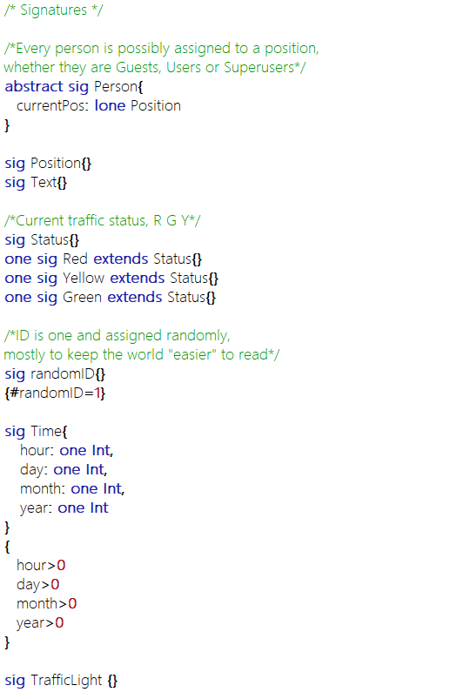

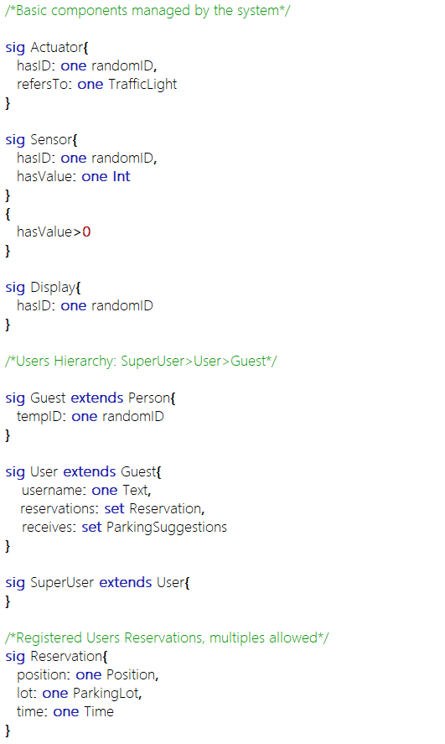

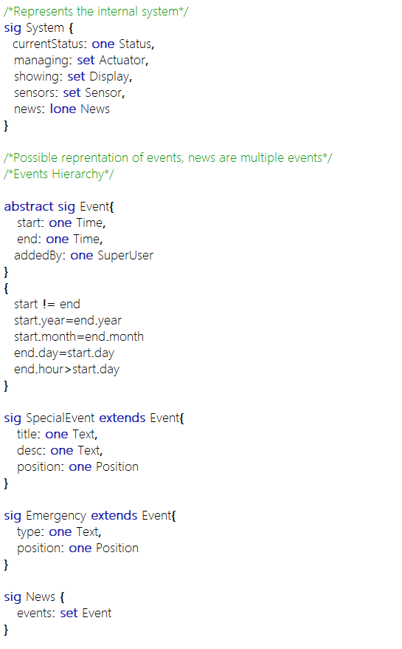

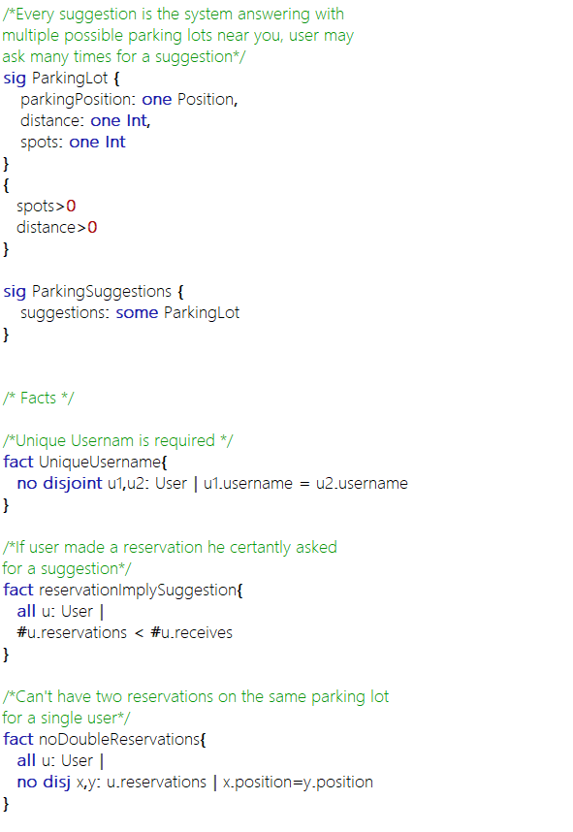

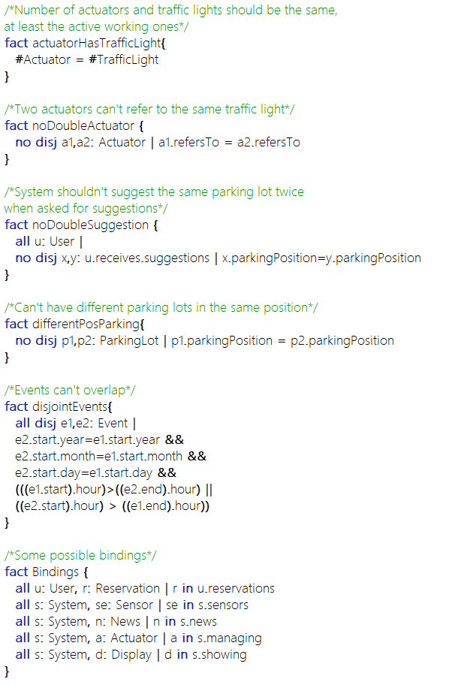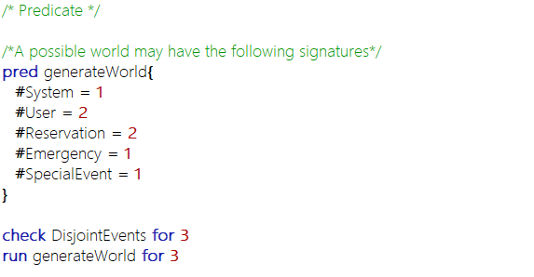

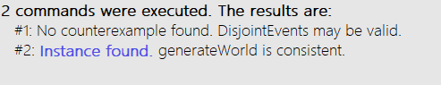

Generated World Template:

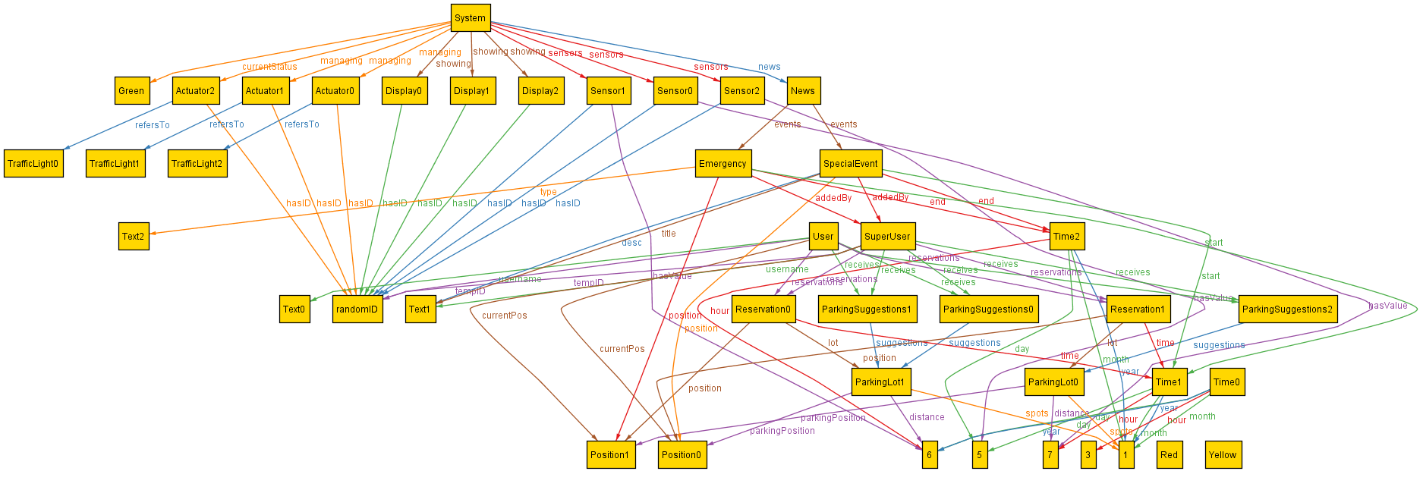

Generated World

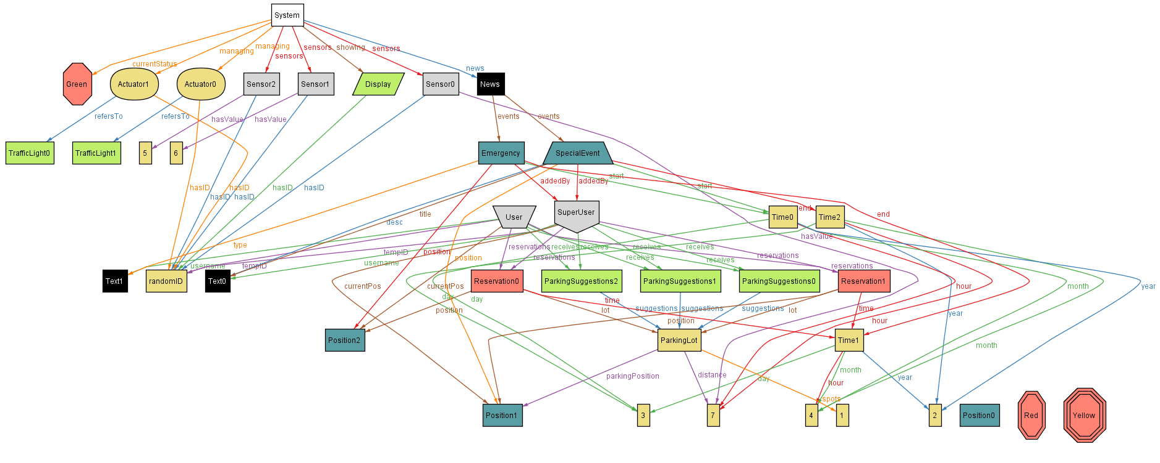Magic Layout:

# 5 – Effort Spent and References

This project has been developed by a single member because of a lack of other teammates, probably because not many other students are taking the second delivery of this year project.

The amount of time needed to complete this document is about 60-70 hours, many of them spent thinking which was the best way to display the information and making/modifying the needed diagrams.

Tools Used:

* The diagrams have been done using the draw.io free tool.
* The wireframes have been realized using Balsamiq.
* Alloy analyzer 4.2 for alloy analysis.
* Microsoft Word to write this document

The commits on GitHub are symbolical of the major steps of the work, as taking the project alone didn’t really require updating the other members and share the work.

A small personal thought is that I feel this kind of projects are much more useful than plain teaching, they are quite funny to develop (this is very personal) and offer many possibilities to look for interesting information online, while learning to use useful tools.